Week 4 Homework Submission File: Linux Systems Administration

Step 1: Ensure/Double Check Permissions on Sensitive Files
- Permissions on /etc/shadow should allow only root read and write access.
  - Command to inspect permissions:
sudo ls -la shadow

  - Command to set permissions (if needed):
sudo chmod 600

- Permissions on /etc/gshadow should allow only root read and write access.
  - Command to inspect permissions:
sudo ls -la shadow

  - Command to set permissions (if needed):
sudo chmod 600

- Permissions on /etc/group should allow root read and write access, and allow everyone else read access only.
  - Command to inspect permissions:
ls -la group

  - Command to set permissions (if needed):
sudo chmod 644

- Permissions on /etc/passwd should allow root read and write access, and allow everyone else read access only.
  - Command to inspect permissions:
ls -la passwd

  - Command to set permissions (if needed):
sudo chmod 600

Step 2: Create User Accounts
- Add user accounts for sam, joe, amy, sara, and admin.
  - Command to add each user account (include all five users):
sudo adduser sam
sudo adduser joe
sudo adduser amy
sudo adduser sara
sudo adduser admin

- Ensure that only the admin has general sudo access.
  - Command to add admin to the sudo group:
sudo usermod -aG sudo admin
sudo cat /etc/sudoers ### then check for the other user names

Step 3: Create User Group and Collaborative Folder
- Add an engineers group to the system.
  - Command to add group:
sudo addgroup engineers

- Add users sam, joe, amy, and sara to the managed group.
  - Command to add users to engineers group (include all four users):
sudo usermod -a -G engineers amy joe sara sam

- Create a shared folder for this group at /home/engineers.
  - Command to create the shared folder:
sudo mkdir /home/engineers/

- Change ownership on the new engineers' shared folder to the engineers group.
  - Command to change ownership of engineer's shared folder to engineer group:
sudo chown :engineers /home/engineers/

Step 4: Lynis Auditing
- Command to install Lynis:
sudo apt-get install lynis

- Command to see documentation and instructions:
man lynis

- Command to run an audit:
sudo lynis audit system

- Provide a report from the Lynis output on what can be done to harden the system.
To harden the system follow the Lynis suggestions.

  - Screenshot of report output: 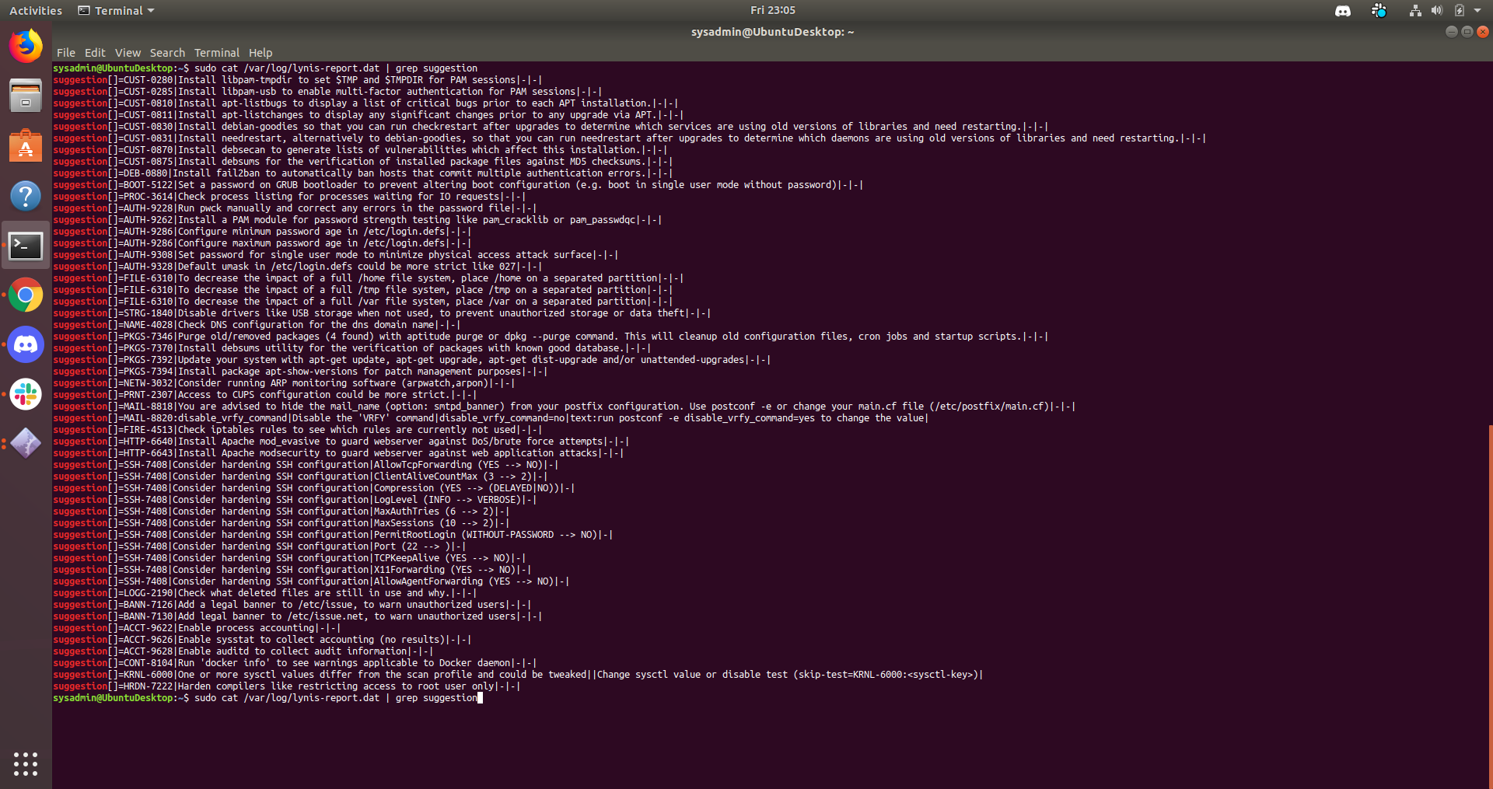

Bonus
- Command to install chkrootkit:
sudo apt-get install chkrootkit

- Command to see documentation and instructions:
man chkrootkit

- Command to run expert mode:
sudo chkrootkit -x

- Provide a report from the chrootkit output on what can be done to harden the system.
Further analysis and/or removal of potentially malicious files such as the one highlighted would harden the system.
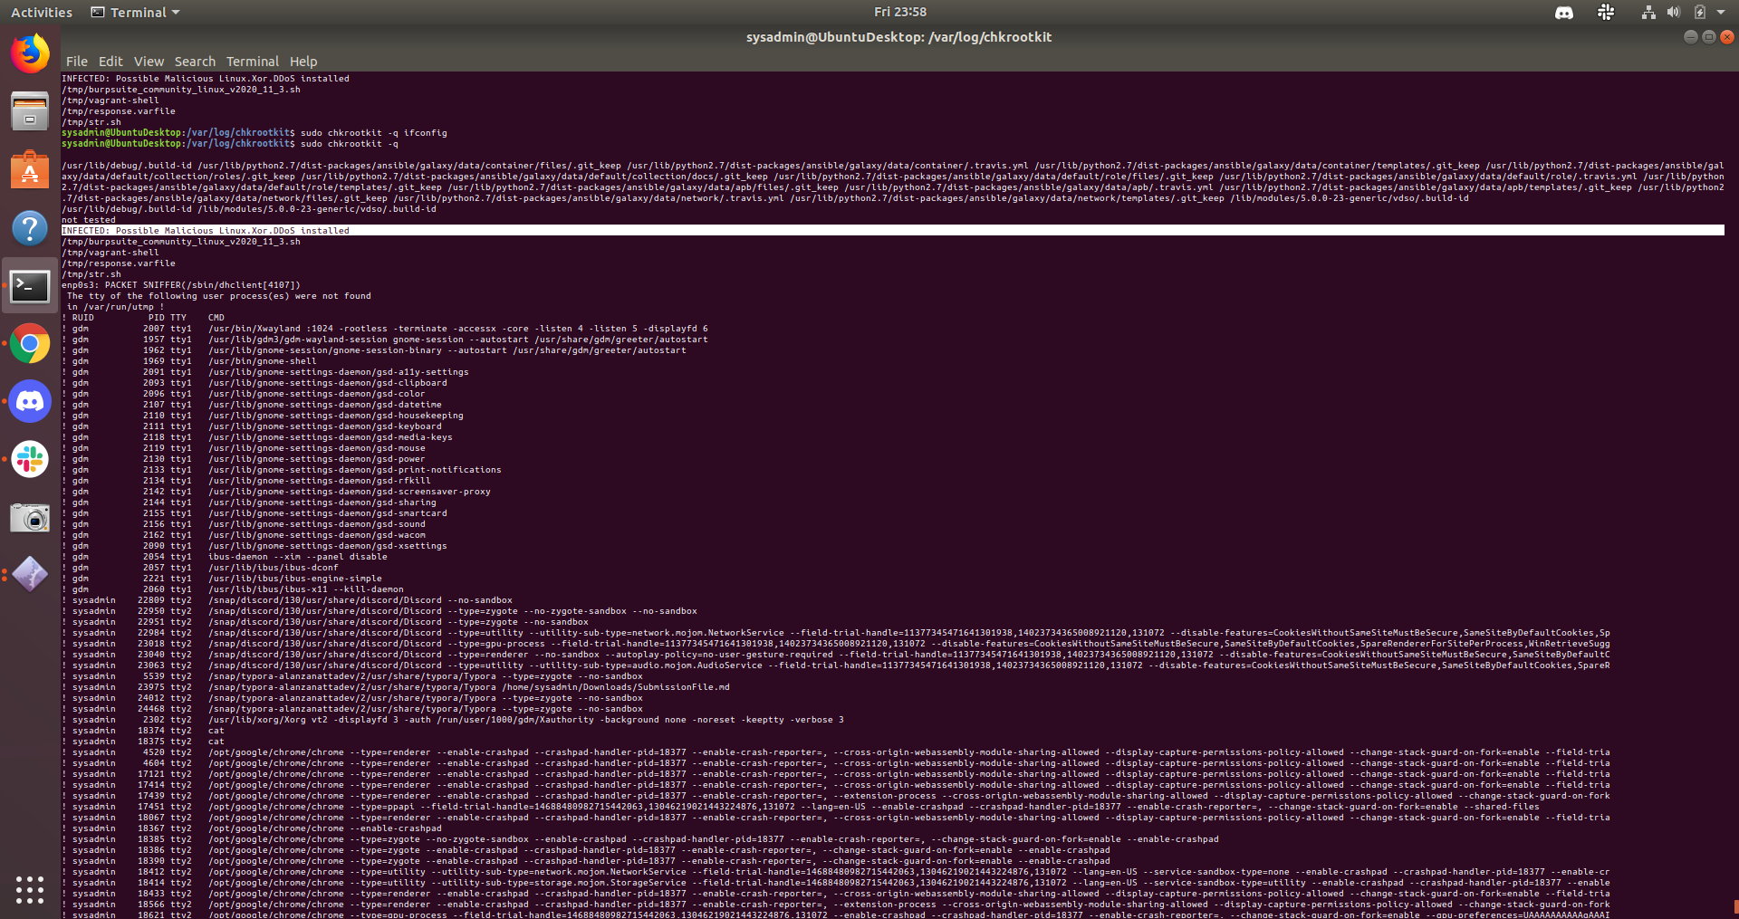
​

Screenshot of end of sample output:
